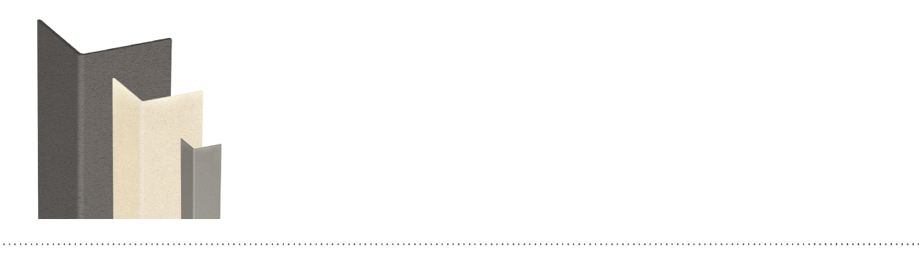

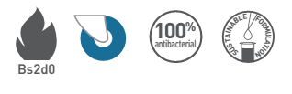

SPECIFICATION

COMBO’LINE 75, 50 AND 25
90° ADHESIVE CORNER PROTECTORS

- Description: 90° adhesive corner protector (Combo’Line 75, 50 or 25 as manufactured by SPM) from slightly textured (Optimixt grain as manufactured by SPM) and antibacterial PVC, 2 mm thick, achieving Bs2d0 fire rating with solid colour. Wings are 75 mm, 50 mm or 25 mm wide (internal measurement). It is provided with 2 strips of foam adhesive tape for fixing (or without adhesive tape on request).
- Environment: no heavy metals and no substance potentially subjected to any REACH restriction are used in its manufacture, nor PBT/BPA. The calcium-zinc thermal stabilization process is used. The emission level of volatile substance in inside air has been tested according to ISO 16000-6 and is very low (A+) according to the French regulation (23 March 2011 nr 2011-321 Decree and 19 April 2011 Order). 100% of the product are recyclable.
- Colour: selected by architects from manufacturer’s standard range.
- Installation method: adhesive. SPM universal mastic glue is recommended for stronger fixing.





